Gym Management System — Developer Guide

1. System Overview
The Gym Management System is a console-based Java application used to manage gym users, memberships, workout classes, and merchandise. The application uses PostgreSQL for persistent data storage and JDBC to communicate between Java and the database.
Users are assigned one of three roles: Admin, Trainer, or Member. After login, the user is directed to a role-specific menu containing only the features available to that role.

2. Architecture Overview
The application follows a layered structure:
Console UI → Service Layer → DAO Layer → PostgreSQL
The menu classes handle user input and display information. Service classes contain validation, calculations, and business logic. DAO classes handle SQL queries and database communication. Model classes represent the data moving through these layers.

Architecture Diagram
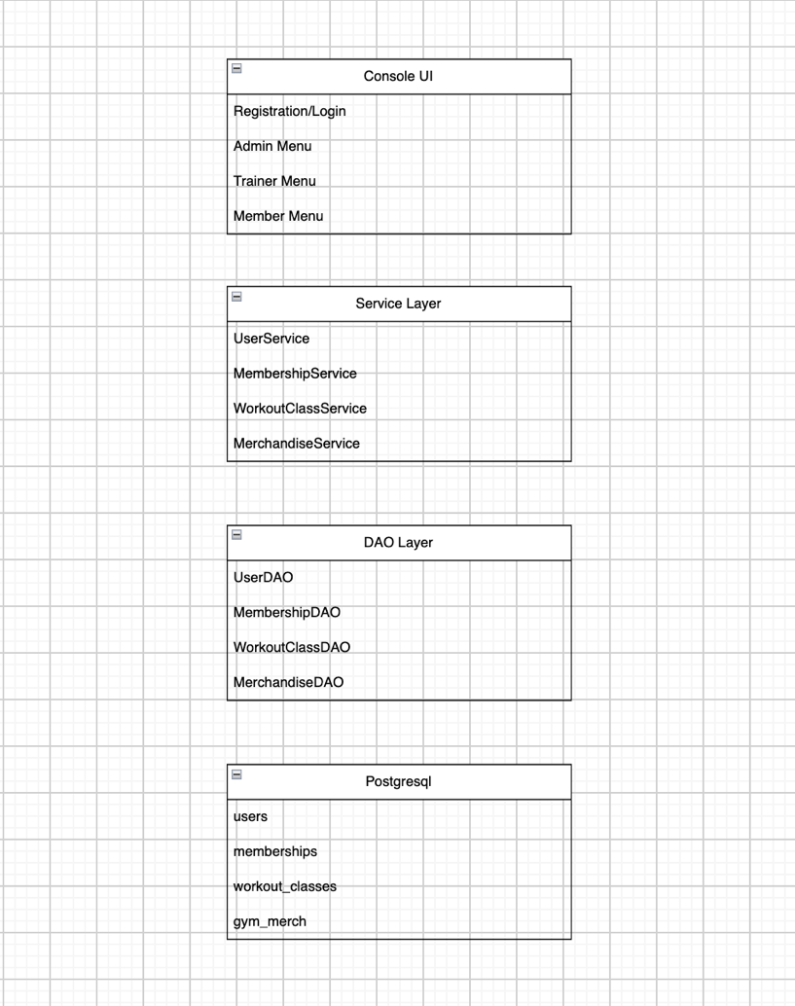

3. Class Design
The project is separated into four main feature areas:
Feature | Model | Service | DAO
Users | User | UserService | UserDAO
Memberships | Membership | MembershipService | MembershipDAO
Merchandise | Merchandise | MerchandiseService | MerchandiseDAO
Workout Classes | WorkoutClass | WorkoutClassService | WorkoutClassDAO
The menu classes are LoginMenu, AdminMenu, TrainerMenu, and MemberMenu. Main handles application startup and directs authenticated users to the appropriate menu based on their role.
The reports package contains MerchandiseReportExporter and MembershipReportExporter, which generate the Admin text-file reports using data retrieved through the existing service layer.
The project mainly uses composition rather than inheritance. Services contain their corresponding DAO objects, while menus use the service classes required for their available features.

UML Class Diagram
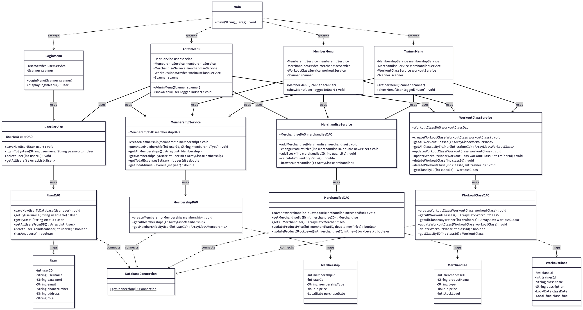

4. Role-Based Access
The application uses separate menus to control what each role can access.
Admin users can manage users, merchandise and workout classes, view membership revenue, and export reports.
Trainer users can manage workout classes, view their assigned classes, purchase/view memberships, and browse merchandise.
Member users can purchase memberships, browse merchandise and workout classes, and view their personal membership expenses.
The logged-in User object is passed from Main to the appropriate menu so actions can be connected to the correct user.

5. User Authentication
Registration and login are handled through LoginMenu, UserService, and UserDAO.
Passwords are hashed using BCrypt before being stored in PostgreSQL. During login, BCrypt compares the entered password with the stored hash rather than storing or comparing plain-text passwords.
The authentication flow is:
LoginMenu → UserService → UserDAO → users table

6. Database Design
The application uses four PostgreSQL tables:
Table | Purpose
users | Stores user credentials, contact information and roles
memberships | Stores membership purchases
workout_classes | Stores workout classes and their assigned trainer
merchandise | Stores merchandise and inventory information
memberships.user_id references users.user_id, allowing one user to have multiple membership purchases.
workout_classes.trainer_id references users.user_id, allowing one trainer to manage multiple workout classes.

Entity Relationship Diagram

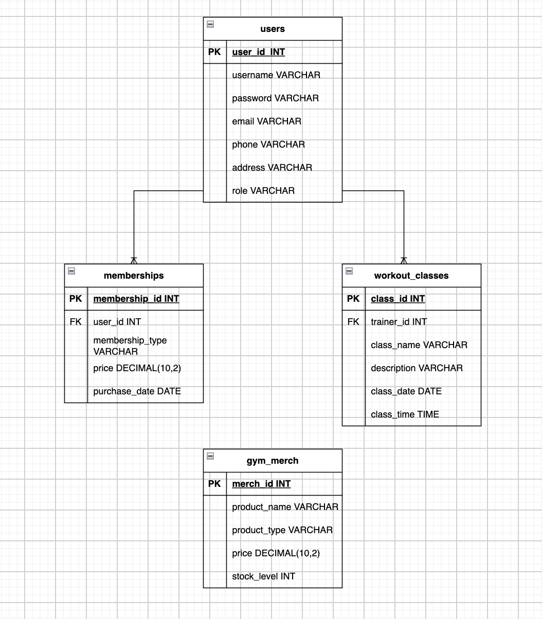

7. Database Integration
The application uses JDBC to communicate with PostgreSQL.
DatabaseConnection provides database connections, which are then used by the DAO classes. The DAOs use PreparedStatement for parameterized SQL queries.
Database operations are kept in DAO classes rather than being written directly inside menus or service classes.

8. Dependencies
The project uses Maven for dependency management.
The main external dependencies are:
PostgreSQL JDBC Driver — allows Java to connect to and communicate with PostgreSQL.
jBCrypt — provides BCrypt password hashing and password verification.
The exact dependency versions are defined in pom.xml.

9. Logging
The application uses Java's java.util.logging framework with a custom AppLogger class.
Logs are written to:
app.log
The application records the required events, including:
- System startup
- Failed login attempts
- Database transaction errors
- Admin actions
The generated app.log file is excluded through .gitignore.
Logging provides a persistent record of important application activity that can still be reviewed after the console application closes.

10. Admin File Export
The Admin menu includes an Export Reports to File option. The Admin can choose between two reports:
- Merchandise Inventory Report — displays current merchandise records, stock levels, individual item values, and total inventory value.
- Membership Revenue Report — displays current membership records and total membership revenue.
The export feature uses two classes:
- MerchandiseReportExporter
- MembershipReportExporter
Each exporter retrieves current data through the existing service and DAO layers rather than creating duplicate database queries.
The export flow is:
AdminMenu → Report Exporter → Service → DAO → PostgreSQL → .txt File
Reports are written to:
/reports/
The generated files are:
reports/
├── merchandise_report.txt
└── membership_revenue_report.txt
Before writing a report, the exporter checks whether the /reports/ directory exists. If it does not exist, Java's File class and mkdir() are used to create it automatically.
The reports are written using FileWriter. A for-loop goes through the returned ArrayList and writes each record in a human-readable format.
FileWriter is opened using try-with-resources, which automatically closes the writer when the operation finishes. This prevents file resources from being left open and helps ensure report data is properly written.

11. Project Structure
src/main/java/com/gymmembership/
│
├── Main.java
├── database/
├── logging/
├── menus/
├── user/
├── membership/
├── merchandise/
├── workout/
└── reports/

docs/
├── user_guide.md
├── developer_guide.md
└── individual-reports/

reports/
pom.xml

12. Setup Instructions
To run the project:
- Clone the GitHub repository.
- Open the project in IntelliJ IDEA.
- Ensure JDK 17 or higher is configured.
- Install and start PostgreSQL.
- Create the project database.
- Run the provided SQL setup script to create the required tables.
- Add the required database credentials to application.properties.
- Use Maven to install the required dependencies.
- Run Main.java.
application.properties is excluded from Git to prevent database credentials from being committed to the repository.

